Introduction
The Independent Review Online Portal is a tool developed to assist Utilization Review Agents (URA) in submitting requests for a review by an Independent Review Organization (IRO) to the Texas Department of Insurance. This manual will guide users on how to enter data through the portal and how to submit it to the Texas Department of Insurance.
Logging Into The Independent Review Portal
To get to the IRO request portal go to Utilization Review Agents (URA) and click on Request for review by an IRO (see below).
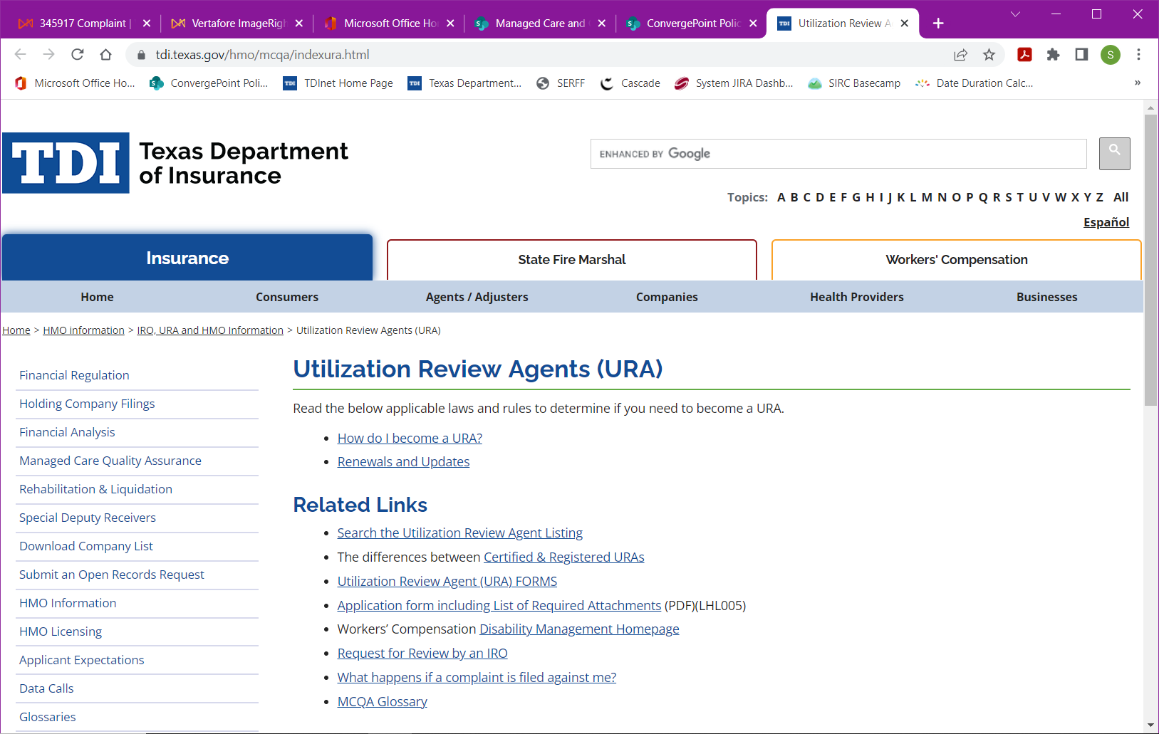
Click Online IRO Request System (see below). Click (instruction manual) to access instructions.
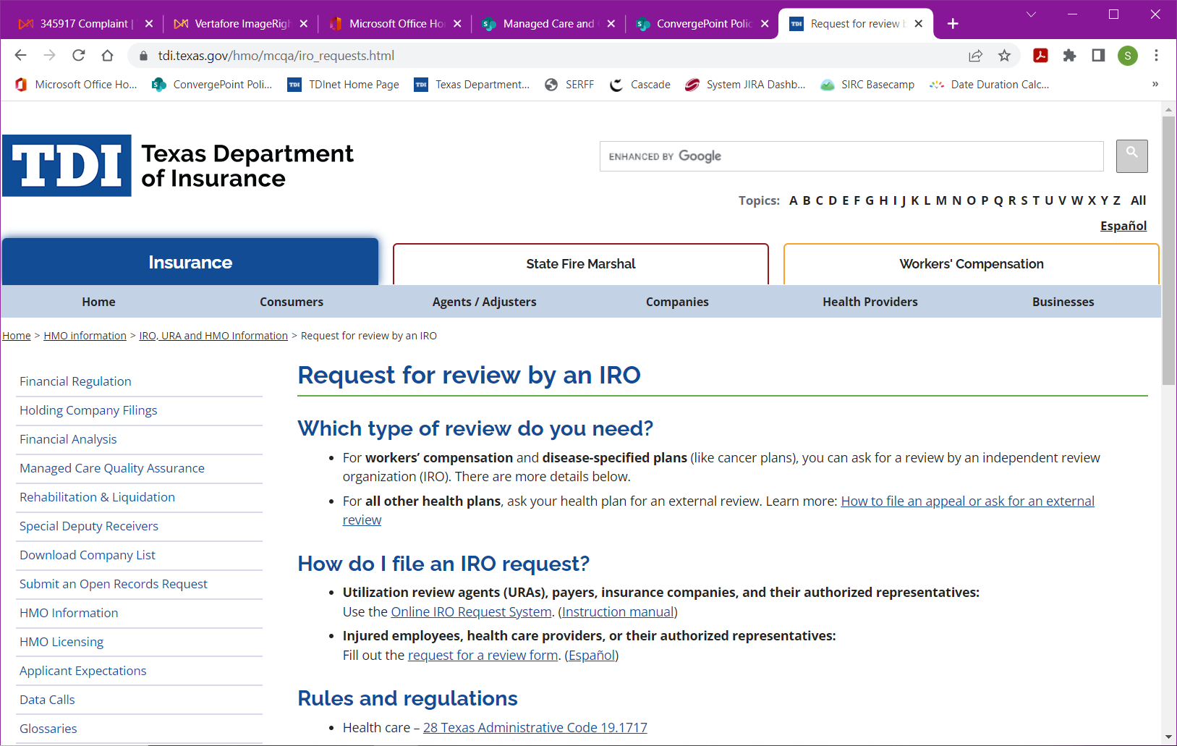

To log into the portal, users will need to know their URA license number and PIN.
If you do not know or have forgotten your PIN, you can use the “Need PIN?” link on the login page to obtain the name and contact information for the individual with your company who is responsible for your PIN.
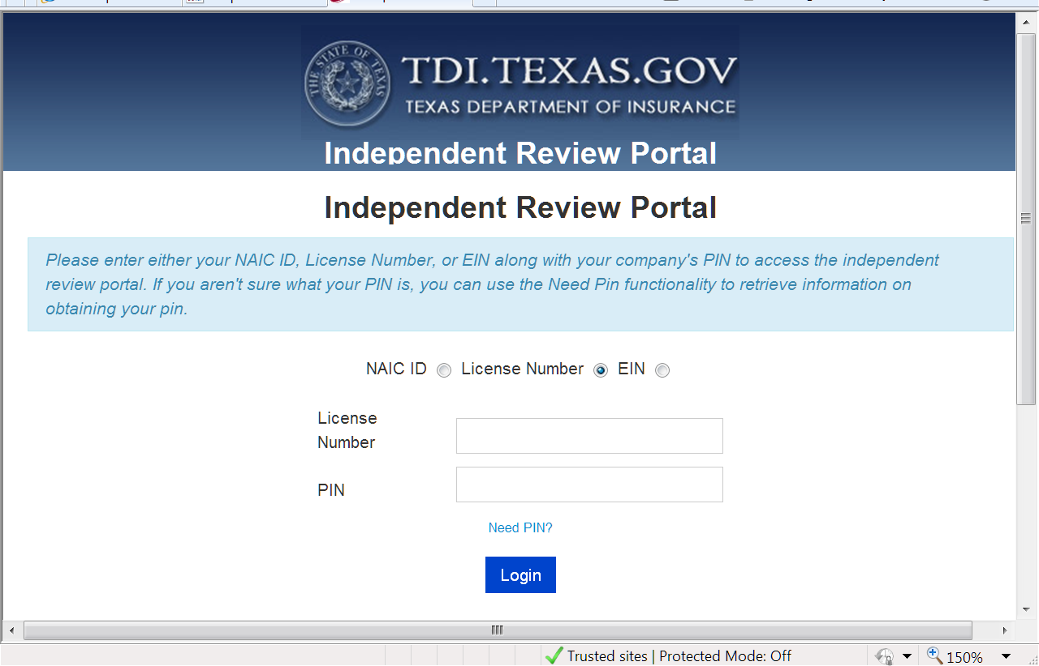
Enter your company’s URA license number and PIN and click Login.

If you do not know your company’s URA license number go to Find and run a report, click Utilization review agent/Independent review organization (see below).
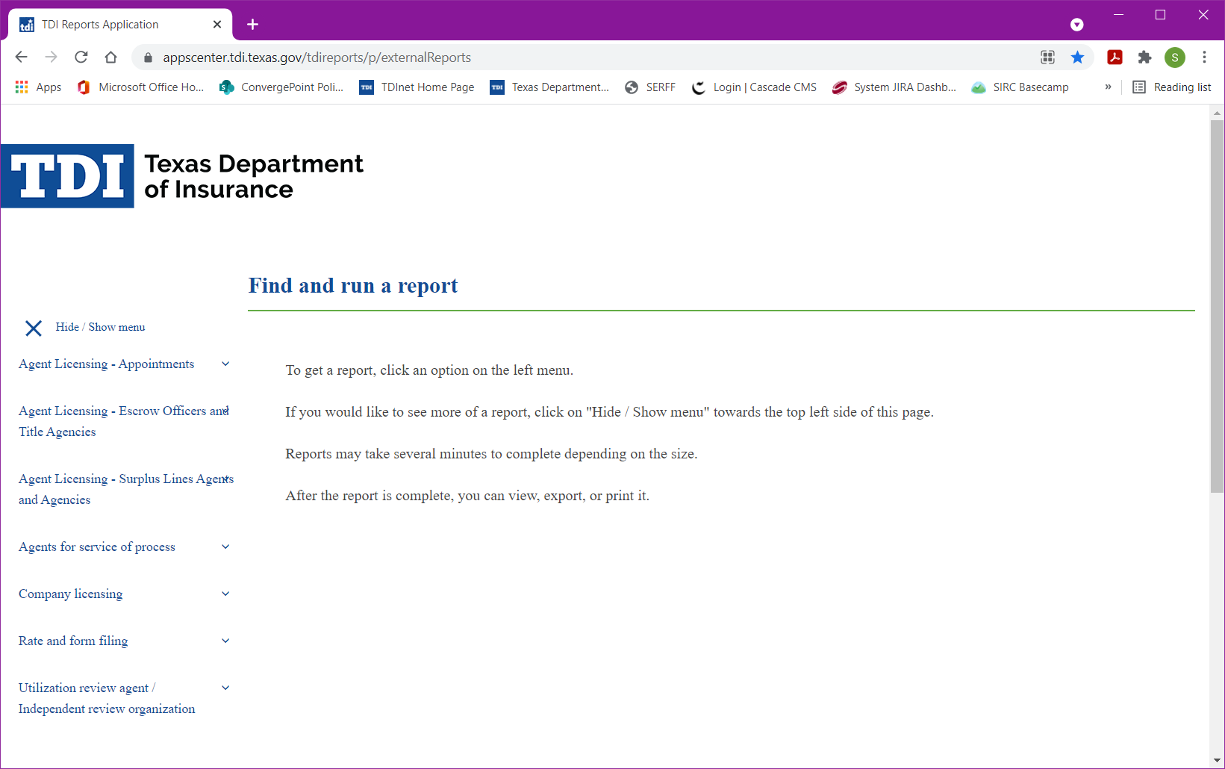

Click Certified / registered URA search (see below).
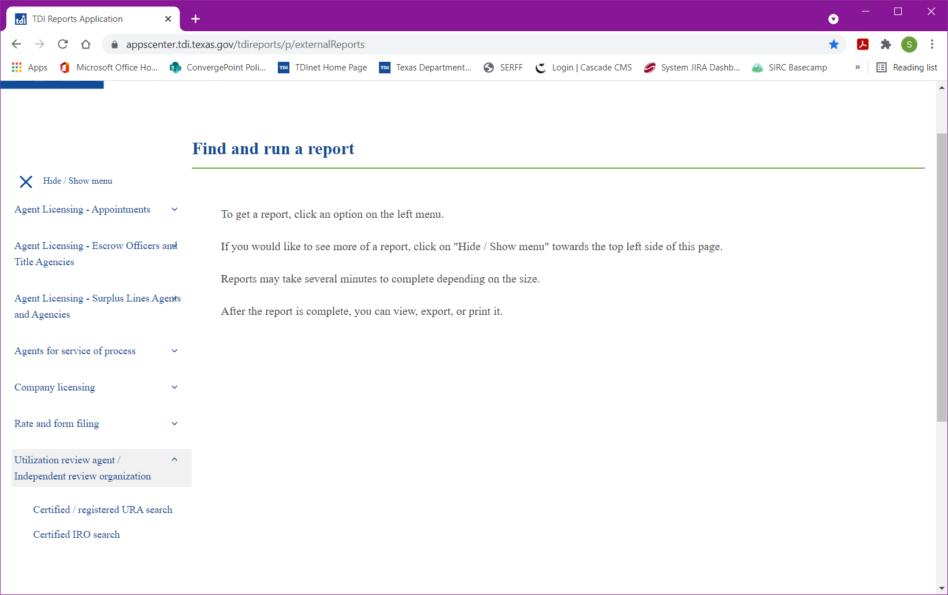

Click Run Report (see below).
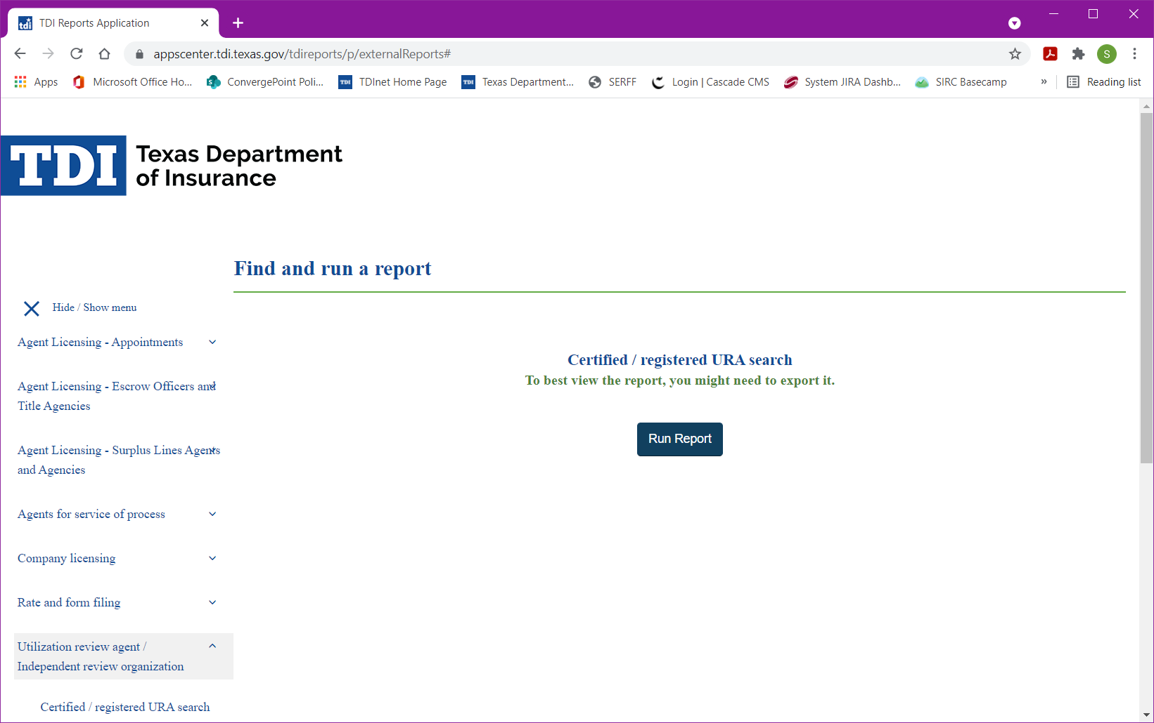

Click Export (see below).
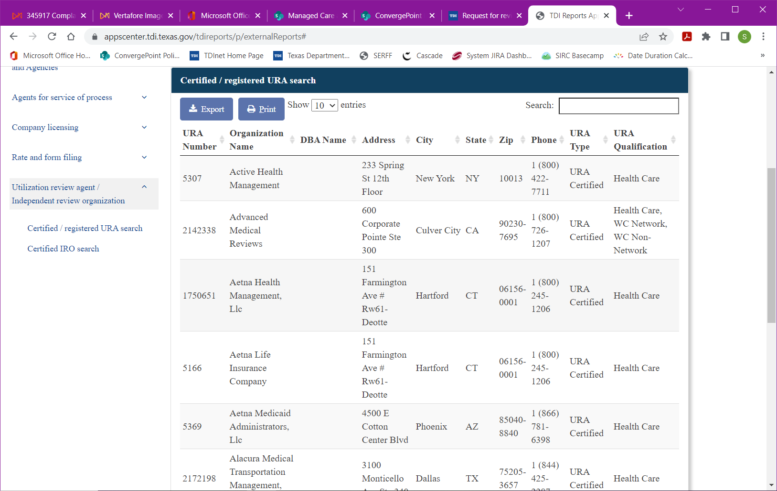

Click Excel (see below). This will open in Excel for you to view all URA Companies.
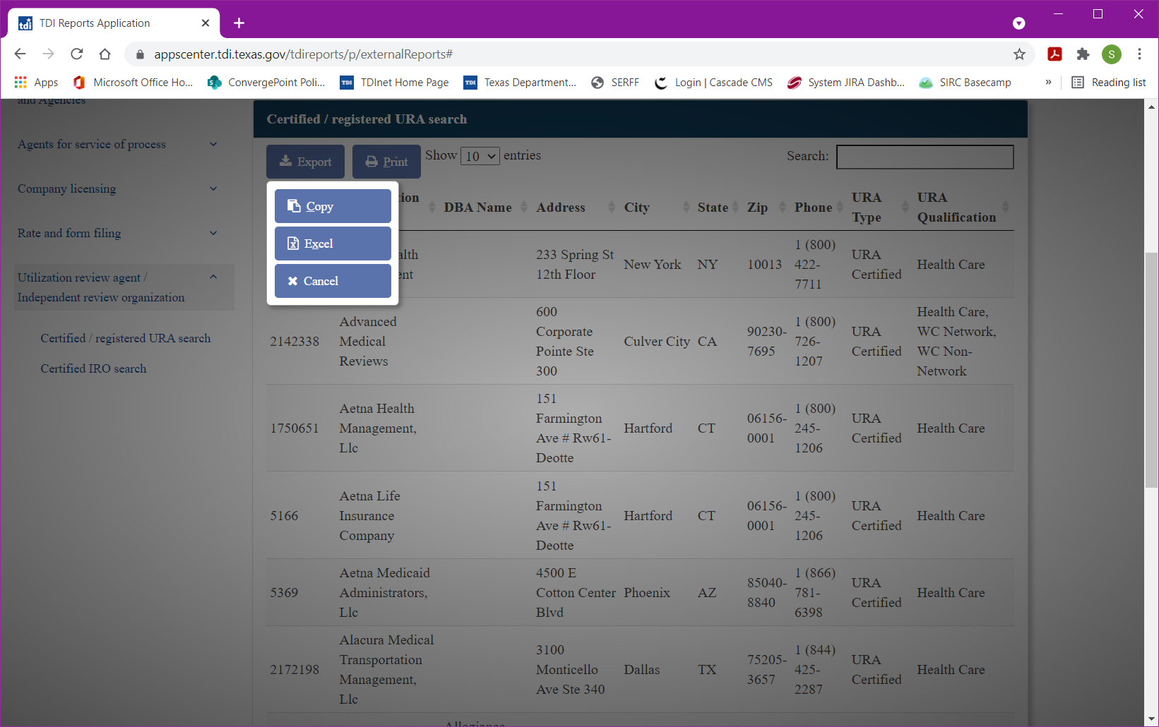

IRO Request Details
The first page that appears is the IRO Request Details. The company information automatically populates in the first section.
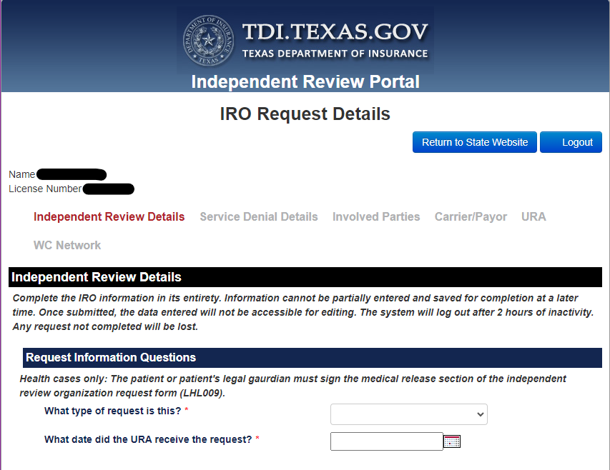
Just below the company information are the navigation links. They are:
Independent Review Details
Service Denial Details
Involved Parties
Carrier/Payor
URA
WC Network
In this example the Independent Review Details section is highlighted.
You will have to complete the IRO request details in its entirety. Information cannot be partially entered and saved for completion later. Once submitted, the data entered will not be accessible for editing. The system will log out after 2 hours of inactivity. Any request not completed will be lost.
The first section under Independent Review Details is the Request Information Questions. The required questions are marked with an asterisk (*).
Select What type of request and choose one of the four options from the drop down: Concurrent, Preauthorization, Rescission, or Retrospective.
When selecting the type of request, you will be presented with additional questions based on your selection.
When selecting the type of insurance or health care plan, you will be presented with additional questions based on the type selected.
DWC claim number and date of injury apply to Workers’ Compensation insurance types.
Provider request date only applies to Rescission request types.
The next questions require a yes or no if not request type Rescission. Use the arrow to select yes or no.
URA received date is required for all request types.
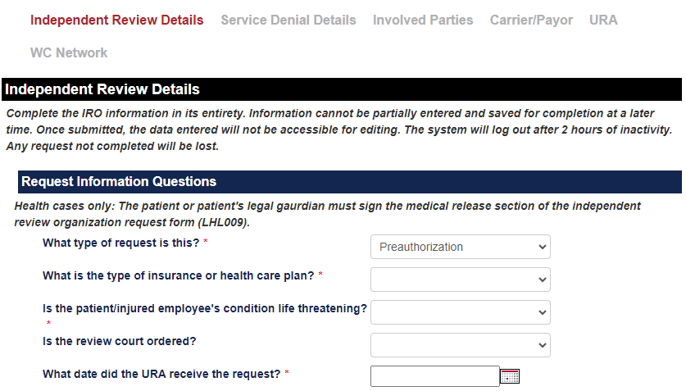
Who is submitting this request?
Select Submitter Type and choose one of the three options from the dropdown: Both, Carrier, or URA. If not rescission, select Both. This will populate all necessary Carrier and URA fields. Enter the name and contact information of the person with the URA or insurance company who is filling out this form. This person needs to be the point of contact for TDI or the IRO, if any questions arise.
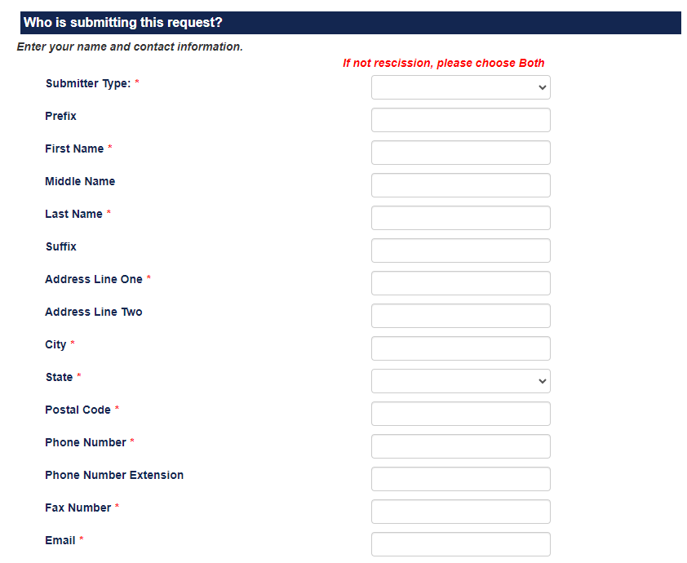
Who is requesting this IRO review?
Enter the information for the party who requested the review by an IRO. This is the party who filled out and submitted the LHL009 (Request for Independent Review) form.
Select the entity type first. If an organization is selected, provide the first and last name of the individual who can be contacted regarding this request.
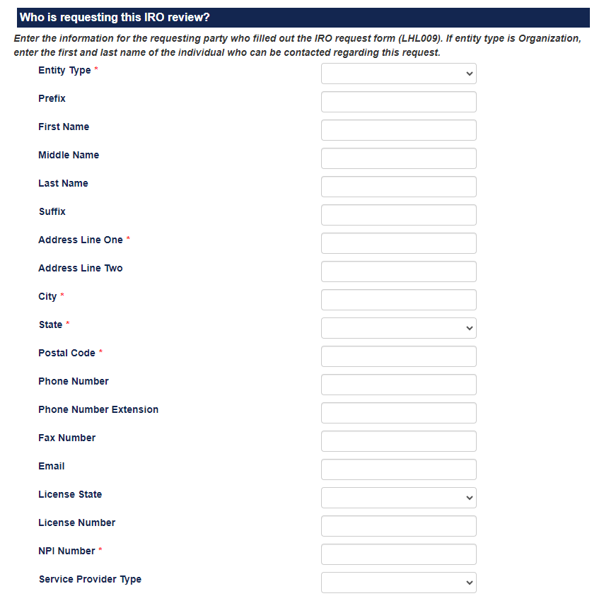
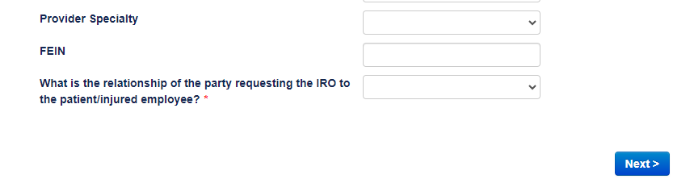
After completing the information, click Next.
Service Denial Details
The service denial information must be completed to the extent of the information you have related to the request.
Click the green plus next to Add Service Denial to add service denial information.
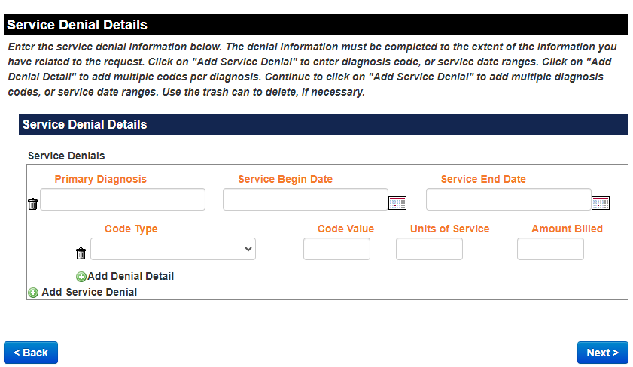
Click Add Denial Detail to add multiple codes per diagnosis.
Click Add Service Denial to add multiple diagnosis codes or service date ranges.
When complete, click Next to continue.
Note: If information is entered in error, click the trash can to delete.
Note: If you want to return to the Independent Review Details page, select Back at the bottom of the page or go to the quick links at the top of the page and click Independent Review Details.
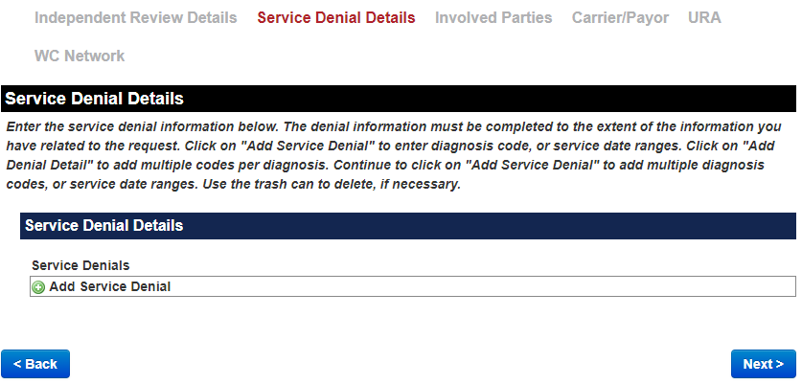
Involved Parties
In this section enter the information for all involved parties. The required fields are marked with an asterisk (*). Although not all fields are required, enter all information that you have.
The Involved Parties are:
Patient/Injured Employee
Provider who received the adverse determination
Other providers with additional information
When entering information in the section Are there any other providers with additional information? Check the box next to Does this situation apply. Additional fields are displayed to enter additional physicians or other health care providers who provided care to the patient and may have records relevant to the review.
If entity type is Organization, then enter the contact information for the individual that can be contacted regarding this request.
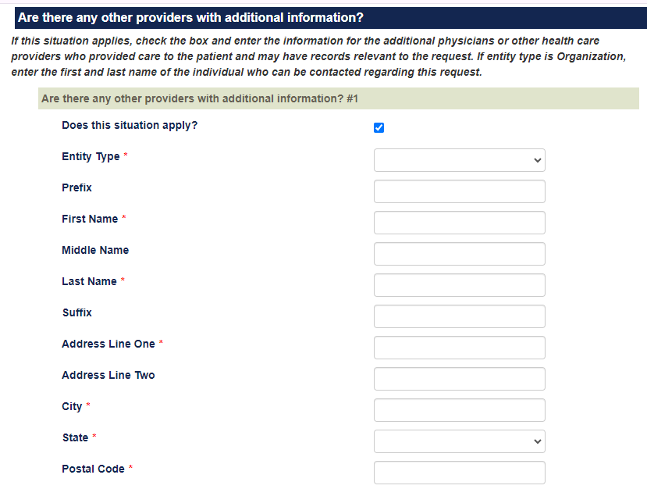
When complete, click Next to continue.
Carrier/Payor
Enter the name of the Carrier or Payor.
Fill in the contact information for the individual who can be contacted regarding this request.
When complete, click Next to continue.
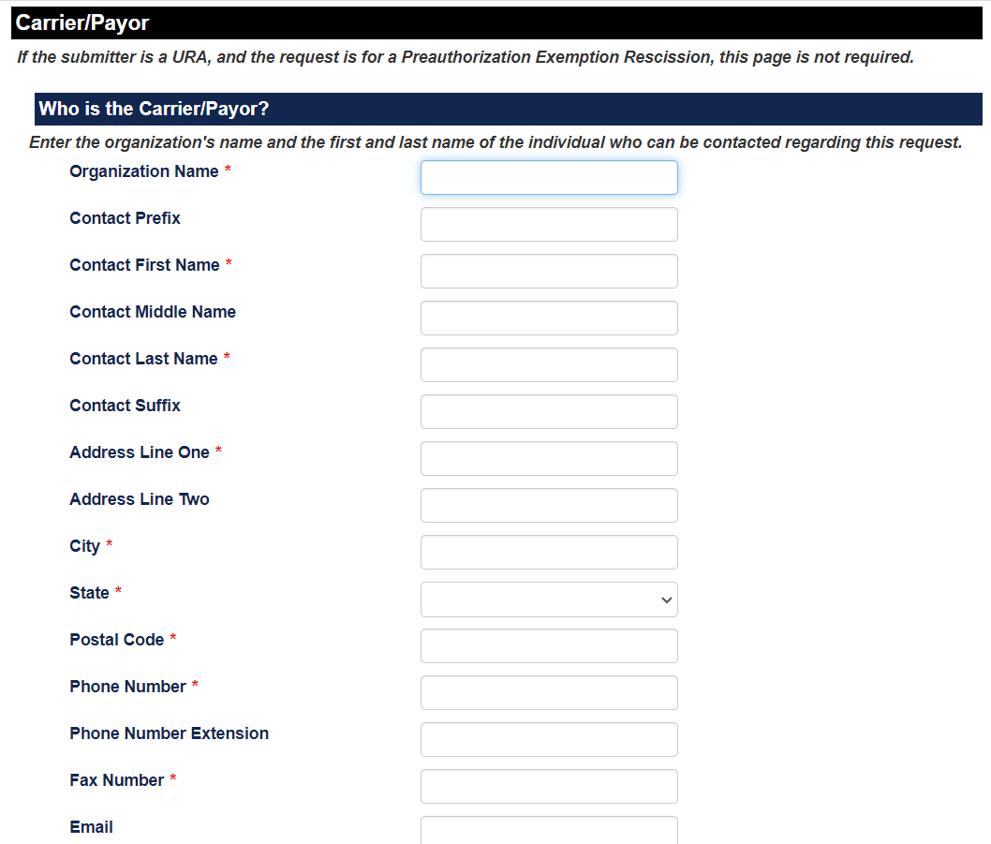
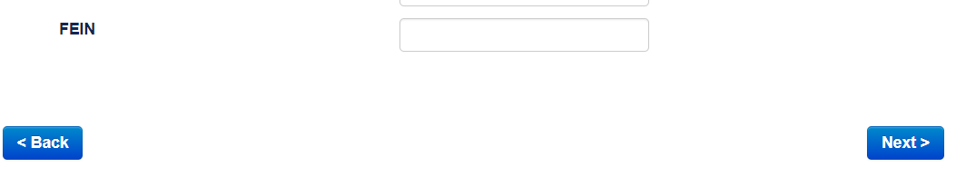
URA
To select a utilization review agent, select from the drop-down menu. Begin typing the name to retrieve.
Fill in the contact information for the individual who can be contacted regarding this request.
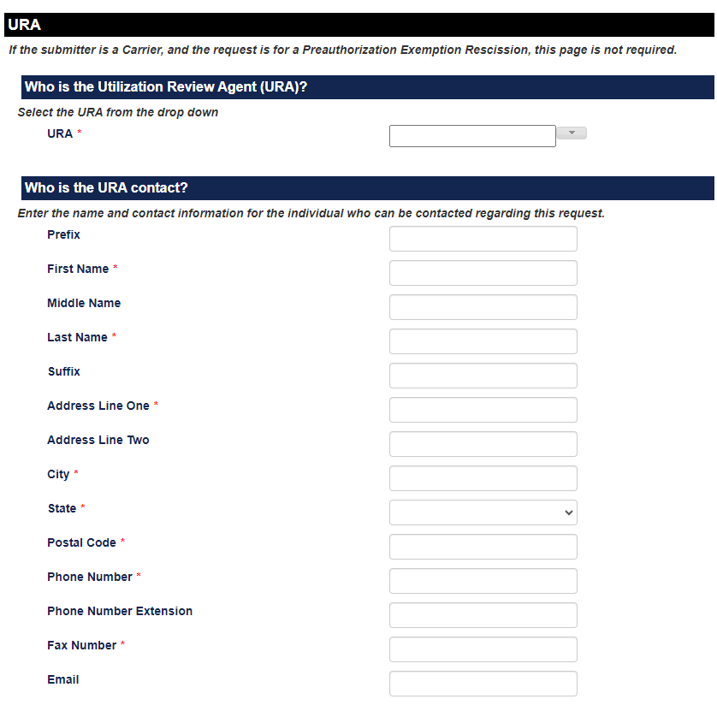
Who is the physician or other health care provider who performed the initial adverse determination
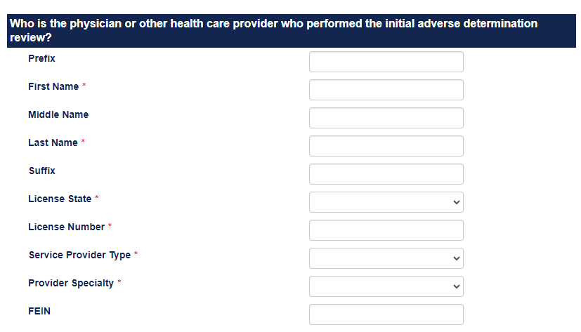
Physician or Other Health Care Provider Who Performed the Appeal
Check the box if there was a reconsideration or appeal performed. Additional fields will be presented for you to populate with information on the physician or other health care provider that performed the appeal.
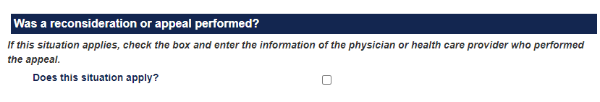
Additional URA Reviewers
Check the box next to Does this situation apply? List any additional physicians or other health care providers who participated in the review/determination of the Utilization Review.
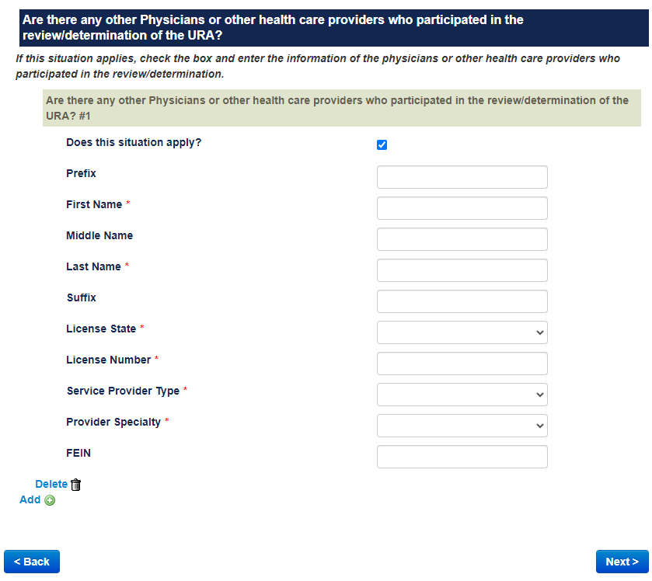
When complete, click Next to continue.
Workers’ Comp Network
If the coverage type is Workers’ Compensation Network, the name of the network must be provided.
Check the box next to Does this situation apply?
Select the network from the drop down. Begin typing the name to retrieve.
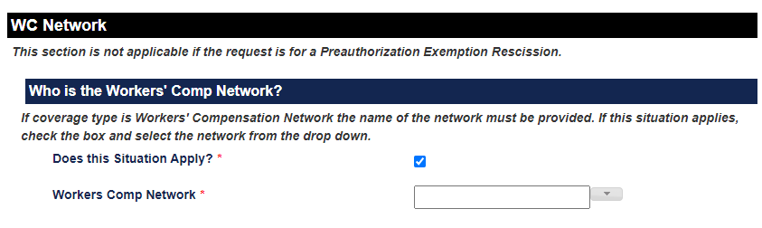
Workers’ Comp Network contact
Check the box next to Does this situation apply?
Fill in the contact information for the individual who can be contacted regarding this request.
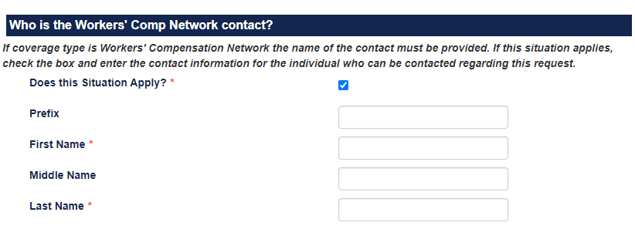
When complete, click Next to continue.
When you have finished adding all the information required in the Independent Review Portal, you are given the opportunity to review the information entered. Review for accuracy.
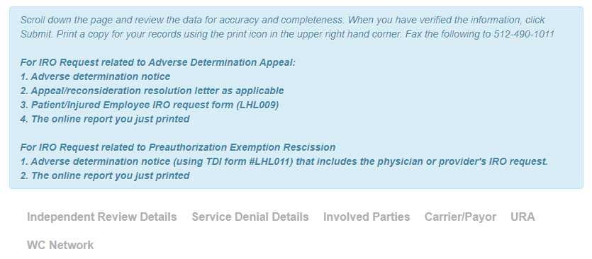
If you discover errors, or need to add additional information, click Back, or use the Quick Links at the top to return to the section you wish to modify.
Once all information has been verified, click Submit.
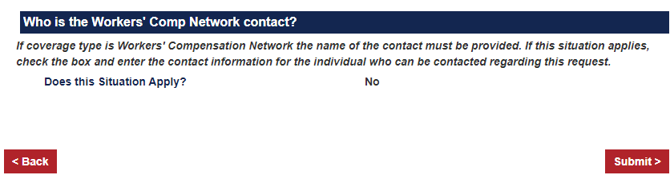
You will see a confirmation page with your Request ID for your records.
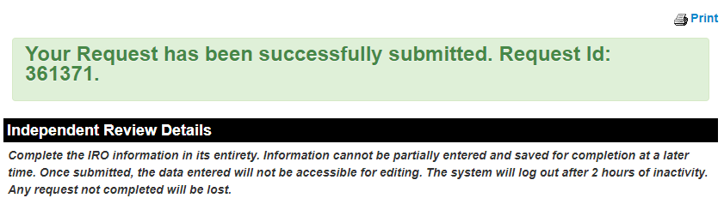
To print a copy of the independent review request, click on the print icon. See above.
You must print a copy of this report and submit it along with the denial letters and the IRO request form (LH009) to the Texas Department of Insurance. Email the information to IRIROPRO@tdi.texas.gov.
You can click on the blue links at the top to Submit Another request, Return to State Website, or Logout.

