Install Certificate

- Double click on DigiCert_IntCA.crt
- Click on Install Certificate…
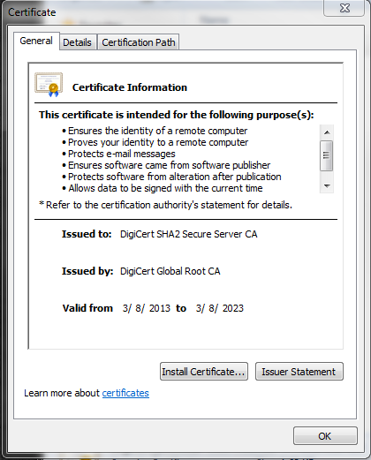

- Click Next
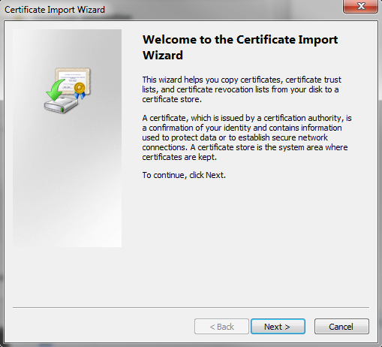

- If asked to install to local machine or local user, select local machine, then click Next

- Verify Automatically select the certificate store based on the type of certificate is checked then click Next
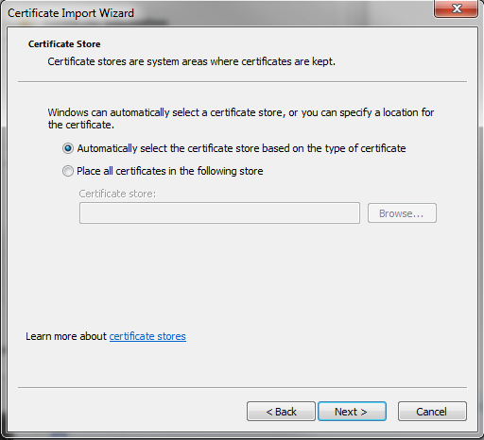

- Click Finish
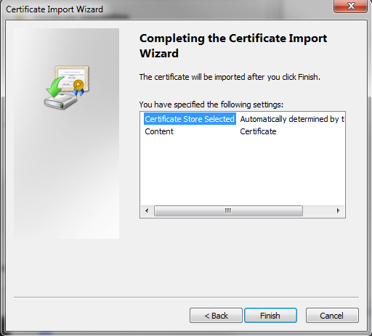

- Double-click

- Click on Install Certificate…

- Click Next

- If asked to install to local machine or local user, select local machine, then click Next

- Verify Automatically select the certificate store based on the type of certificate is checked then click Next

- Click Finish

