TEXAS DEPARTMENT OF INSURANCE

General Instruction Manual for

Texas Title Insurance Agent Experience Report Submission

For inquiries regarding the Title Data Call,
contact TDI’s Data Services at 512-676-6690
All Texas title insurance companies and title insurance agents, whether independent, affiliated, or direct operation, must submit the Texas Title Insurance Agent Experience Report.
Tex. Ins. Code Ann. §2703.153

This manual will assist you in completing the Texas Title Insurance Agent Experience Report Submission using the Texas Department of Insurance interactive PDF form. This electronic, interactive form includes built-in edit checks that allow you to submit your data to TDI via email with minimal errors. This paperless submission method is similar to a paper-based form. The interactive form is accessible from any computer using Adobe Reader, and it allows the user to transfer data via email to other parties, such as TDI, as an attachment.

Before You Begin

Open the interactive PDF form using Adobe Reader. If you do not already have Adobe Reader 7.0 or higher installed on your computer, you may download it free from Adobe at get.adobe.com/reader. Next, you will find the Texas Title Insurance Agent Experience Report Submission form (interactive PDF) on the TDI website. The web address for this form is located at the bottom of this year’s Commissioner’s Bulletin, or you may go to the TDI Title Bulletins web page at www.tdi.texas.gov/bulletins/index.html.

General Instructions

1. The experience report submission forms generally have separate columns for reporting title insurance, escrow, and non-policy abstract experience. These three types of operations are further defined below.

a) Title insurance is the business of issuing title insurance commitments, policies, and forms.
- It includes all activities connected with title search, title examination, furnishing of title evidence, and closing. Include these activities when you expect that policies or forms will be issued by any title insurance agent, direct operation, or underwriter, whether or not they are, in fact, ultimately issued.
- Direct operations: Direct operation activities do not include activities for underwriting, administration, or claim settlements.

b) Escrow is the business that relates to the fiduciary function of receiving, accounting for, and disbursing funds held in escrow for a real estate transaction. If you do not expect that policies or forms will be issued and, in fact, none are ultimately issued, it includes obtaining, signing, copying, certifying, or delivering documents related to the transaction.

c) Non-policy abstract is the business that generates non-policy abstracts, abstract certificates, and non-policy-related abstract fees. You conduct non-policy abstract business when you do not expect to issue a title insurance policy or form.

2. Show income and expenses from each of the operations (title, escrow, and non-policy abstract) in their respective columns. If you can determine the exact expense for each operation, allocate the expenses directly (direct allocation). Include expenses required to qualify for and maintain a direct operation or agent's license, including nonrefundable license fees, annual audits, and bonds for agents and direct operations, as direct expenses in the title insurance column.

If you are unable to allocate directly, you may use another equitable and reasonable method. One way is to allocate expenses in the same ratio that each individual operation’s income bears to the total income for the applicable operations, or, depending on the expense to be allocated, you may allocate on the basis of square feet or on the number of employees devoted to the three operations. If expenses are associated with business activities other than the three operations, you must allocate some portion of the expenses to these other activities. See the next page for examples of allocation based upon income.

Case 1: You have a $750 expense to be allocated to all three operations.

Assume your total from each column on Form A, line A.14 is

Title $40,000
Escrow $10,000
Non-Policy Abstract $25,000
Total $75,000

To find allocation percentages

Title $40,000/$75,000 = 53%
Escrow $10,000/$75,000 = 13%
Non-Policy Abstract $25,000/$75,000 = 33%

Allocation amounts are then determined

Title $750 x .53 = $398
Escrow $750 x .13 = $ 98
Non-Policy Abstract $750 x .33 = $248
$744

The calculations produce a rounding difference of $6 ($750 - $744 = $6). Simply adjust your figures to make up the $6 difference.

Title $400
Escrow $100
Non-Policy Abstract $250
Total $750

Case 2: You have a $900 expense to be allocated between only Title and Non-Policy Abstract.

Assume your total from each column on Form A, line A.14 is

Title $40,000
Escrow $10,000
Non-Policy Abstract $25,000
Total $75,000

Add the amounts for the two operations involved in this allocation

Title $40,000
Non-Policy Abstract $25,000
Total $65,000

To find allocation percentages

Title $40,000/$65,000 = 62%
Non-Policy Abstract $25,000/$65,000 = 38%

Allocation amounts are then determined

Title $900 x .62 = $558
Non-Policy Abstract $900 x .38 = $342
Total $900
The Texas Title Insurance Agent Experience Report Submission form (interactive PDF) includes an option for automatic allocation of expenses based on income method. Read through the entire instructional page for more information about this option.
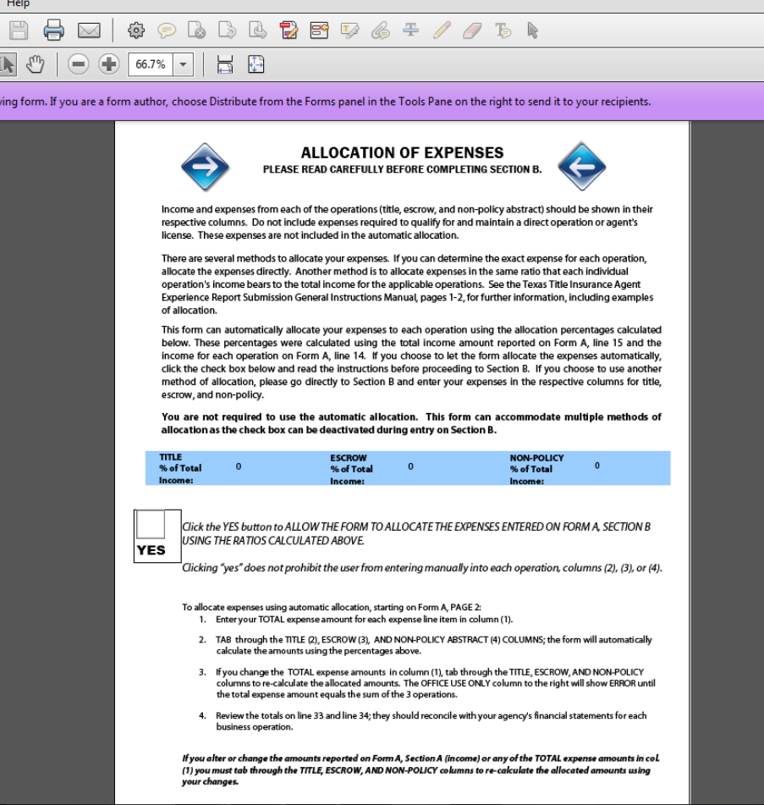
3. Do not include income or expenses for any other business operation in this submission. However, if the books and records that support amounts shown in this submission include income or expenses for other business operations, you must complete the Allocation Reconciliation Worksheet form and retain it with the books and records used to complete this submission.
Do not submit the Allocation Reconciliation Worksheet with the experience report. Maintain the Allocation Reconciliation Worksheet with your records and ensure that it is available at all times for examination by TDI personnel.

4. Maintain underlying data, individual source documents, and other information you use to develop your experience report submission in your records for a minimum of five years after the submission due date.

5. Do not report distributions, such as partnership or “S-Corp” distributions, on Form J.

6. If your agency changes ownership during the reporting year resulting in a change in agency type, report the agency type that represents the longest time span during the reporting year. If the time spans are equal, use the agency type from the earlier period.

Agency General Information
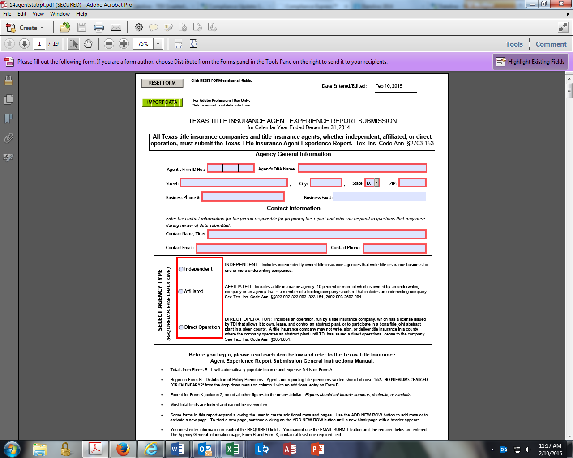

General Information:
Title Agent’s Name: Use DBA if applicable.
Agent’s Firm ID Number: You can find this information on TDI’s website at https://apps.tdi.state.tx.us/sfsdatalookup/StartAction.do, selecting Title Agent/Escrow, and then selecting the desired report.
Independent: Describes independently owned title insurance agencies that write title insurance business for one or more underwriting companies.
Affiliated: Describes a title insurance agency 10 percent or more of which is owned by an underwriting company, or an agency that is a member of a holding company structure that includes an underwriting company. See Tex. Ins. Code Ann. §§823.002-823.003, 823.151, 2602.003, and 2602.004.
Direct Operation: Describes an operation run by a title insurance company, which has a license issued by TDI that allows it to own, lease, and control an abstract plant, or to participate in a bona fide joint abstract plant in a given county. A title insurance company may not write, sign, or deliver title insurance in a county where the company operates an abstract plant until TDI has issued a direct operations license to the company. See Tex. Ins. Code Ann. §2651.051.

Title Premiums – Form B
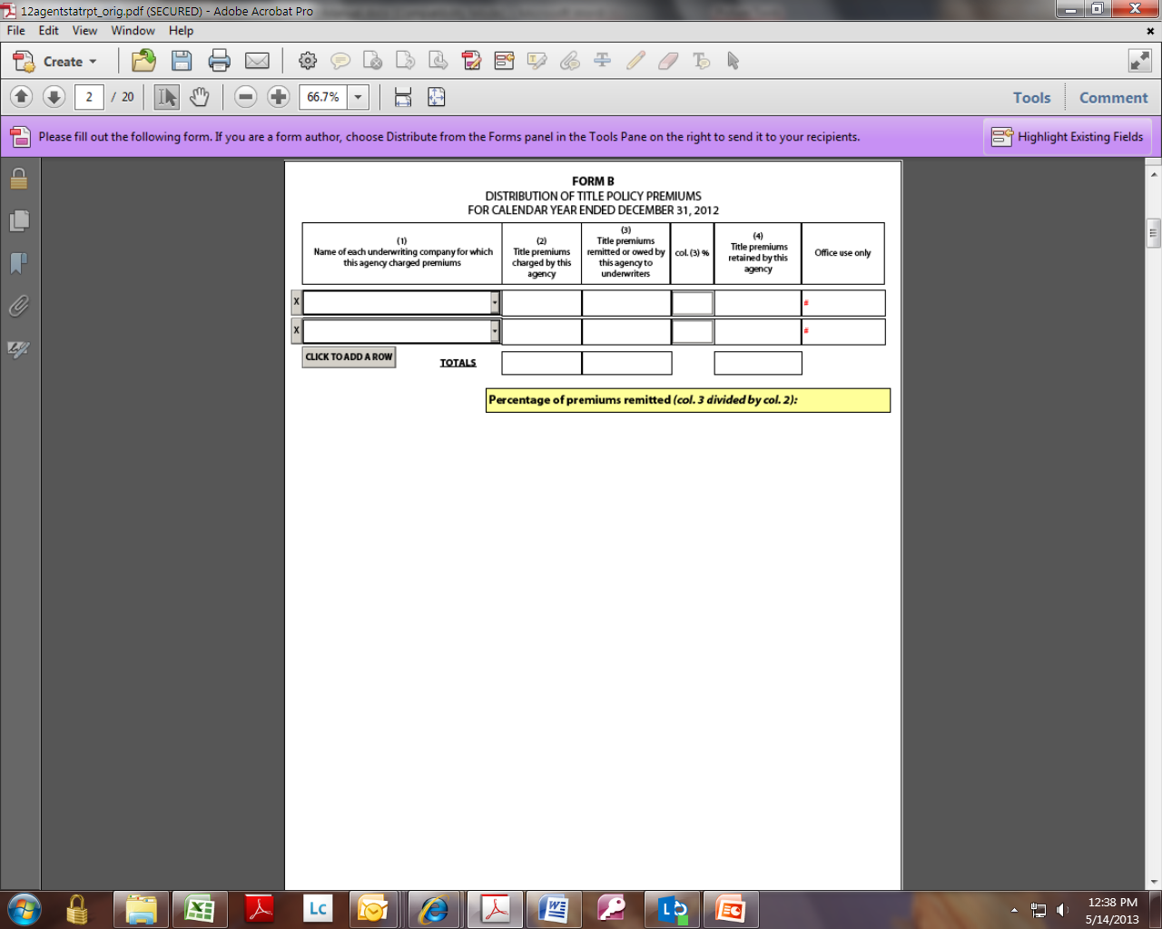

General Information:
Title Premiums (Form B, column 2; Form A, line A.1): Include all premiums collected during the calendar year for policies, binders, and endorsements that have been or will be issued by your agency. Only report premiums for policies written in counties where you are licensed. The total premium on Form B (col. 2) should equal Form L total of Title Premiums Charged (col. 2) and Form A, line A.1.
Show income received for out-of-county transactions as fees received for closing on Form D. Do not report any expenses paid or premium splits paid on out-of-county transactions on Form F.
Remitted Title Premiums (Form B, column 3; Form A, line A.2): Include the portion of premiums collected during the calendar year that were either remitted to or owed to title underwriting companies.
- Direct operations: Include the portion of gross premiums allocated to the underwriter function.
Retained Title Premiums (Form B, column 4; Form A, line A.3): Include the portion of premiums your agency collected during the calendar year. This is the amount of premium before splitting with attorneys or other title agents.
- Direct operations: Include the portion of gross premiums not allocated to the underwriter function.

Examination Fees – Form C
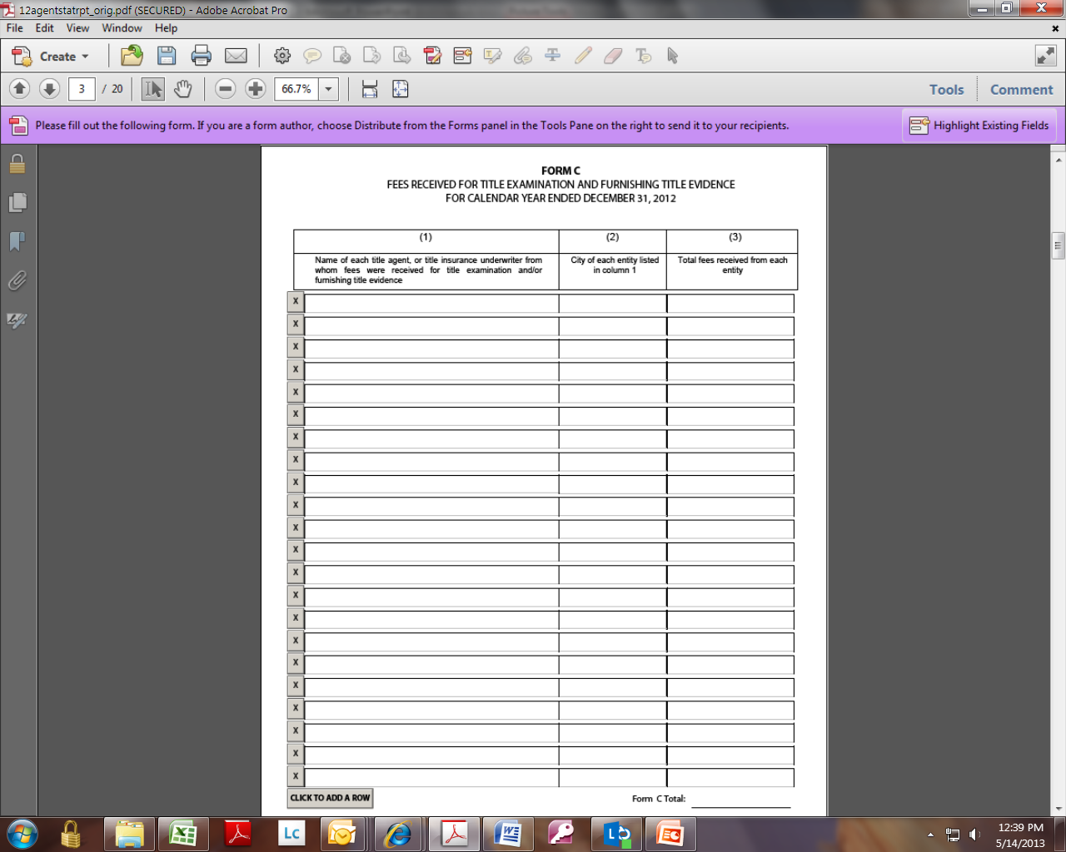

General Information:
Fees Received for Title Examination and Furnishing Title Evidence (Form C, column 3; Form A, line A.4): Report the portion of premiums received from other title insurance agents or underwriters for title examination and furnishing title evidence when the other agents or underwriters issued the policies.

Fees Received for Closing Services – Form D
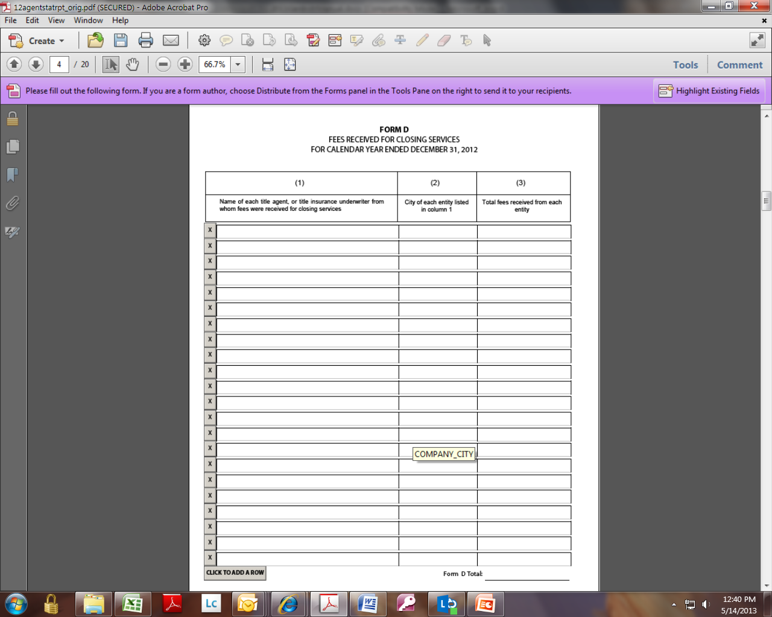

General Information:
Fees Received for Closing Services (Form D, column 3; Form A, line A.5): Report the portion of premiums received from other title insurance agents or underwriters for closing transactions when other agents or the underwriters issued the policies. Show any income received for out-of-county transactions as fees received for closing on Form D by reporting the name of the underwriter, city of the underwriter, and net retained premium for the out-of-county transactions. Do not report any expenses paid or premium splits paid to other agents on out-of-county transactions on Form F.

Other Income – Form E
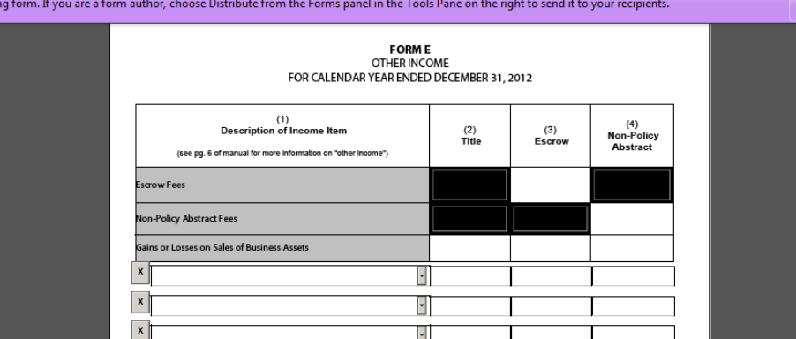

General Information:
Other Income (Form E, columns 2, 3, and 4; Form A, line A.13): Do not show income for items listed on Form A, lines 1-12.
Title Insurance (column 2): Include other income, such as tax refunds, plant or lease update fees, and copy charges.
Escrow (column 3): Include escrow fees or other fees that are not passed through to third-party vendors.
Non-Policy Abstract (column 4): Include all non-policy-related abstract fees. Do not include any premiums or escrow fees.
Gains or Losses on Sale of Business Asset (columns 2, 3, and 4): Include only the portion of proceeds from the sale of business assets that represents the gains or losses on the sale of those assets. Show loss amounts as a negative income.

Fees Paid for Title Examination and Furnishing Title Evidence – Form F
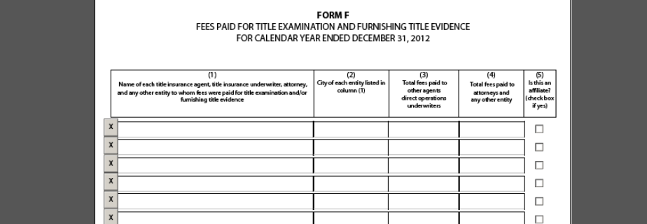

General Information:
Fees Paid for Title Examination and Furnishing Title Evidence (Form F, columns 3 and 4; Form A, lines B.3a and B.3b): Report the portion of premiums paid to nonemployees for title examination and furnishing title evidence when your agency issued the policies. Do not show any expenses paid or premium splits paid on out-of-county transactions. If you include any expenses on Form F, those should only be for properties in counties where you are licensed.
If you paid an affiliate, put an "X" in column 5. Tex. Ins. Code Ann. §823.003(a) defines an affiliate as a person who “directly or indirectly through one or more intermediaries controls, is controlled by, or is under common control with the other person.”

Fees Paid for Closing Services – Form G
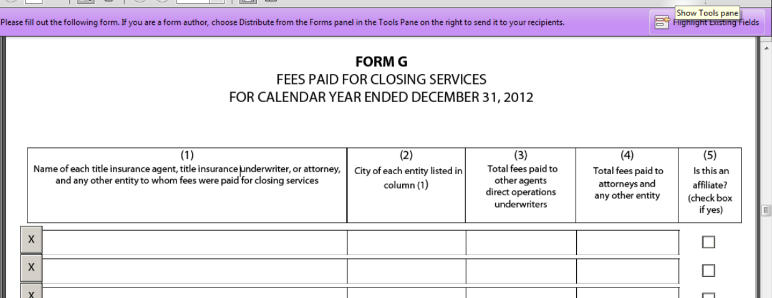

General Information:
Fees Paid for Closing Services (Form G, columns 3 and 4; Form A, lines B.4a and B.4b): Report the portion of premiums paid to nonemployees for closing transactions when your agency issued the policy.
If you paid an affiliate, put an "X" in column 5. Tex. Ins. Code Ann. § 823.003(a) defines an affiliate as a person who “directly or indirectly through one or more intermediaries controls, is controlled by, or is under common control with the other person.”

Recapitulation of Directors’ Fees – Form H
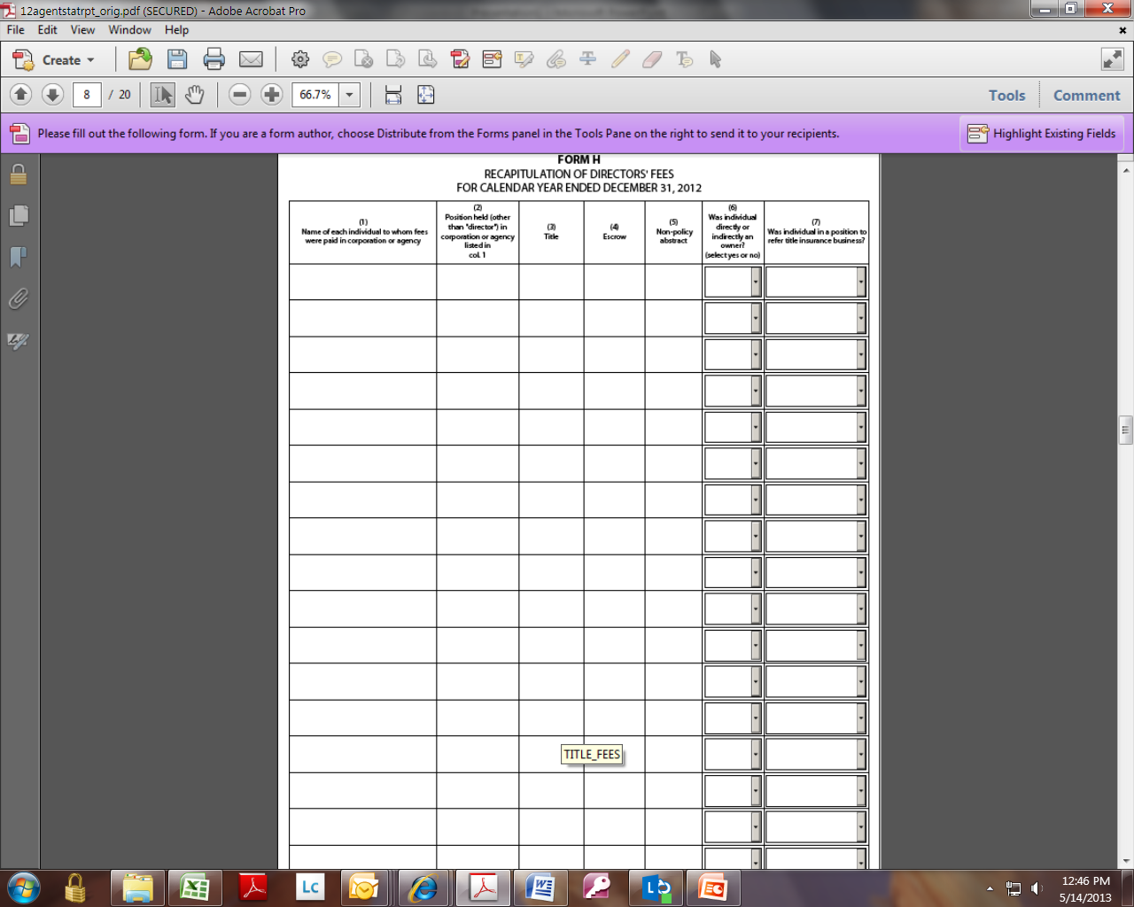

General Information:
Recapitulation of Directors’ Fees (Form H, columns 3, 4, and 5; Form A, line B. 21): Include all amounts paid to corporate directors. Do not include any amounts reported under Salaries on line B.1.

Losses and Loss Adjustment Expenses – Form I
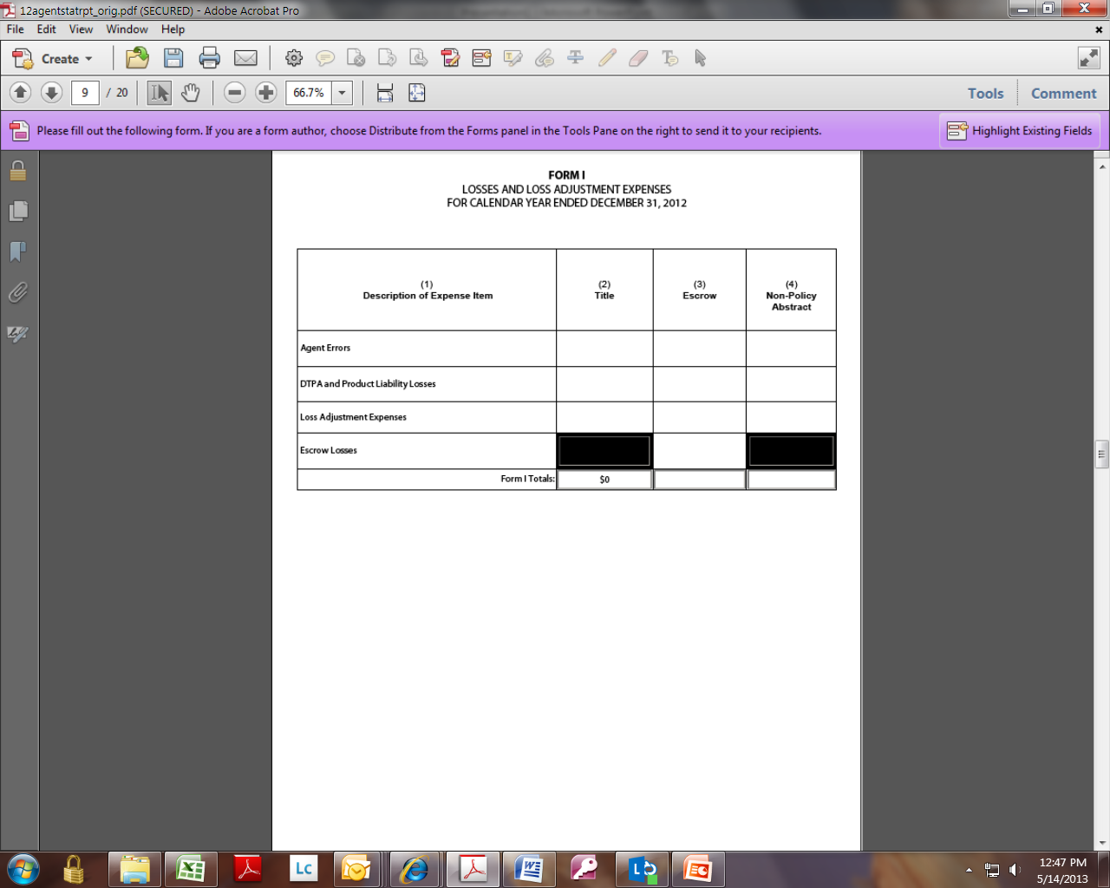

General Information:
Losses (Form I, columns 2, 3, and 4; Form A, line B24): Do not include losses that have been paid or that will be paid by an underwriter. Report amounts paid by an agent to reimburse an underwriter for all or a portion of a claim as losses or loss adjustment expenses for the agent.
Escrow Losses: Include losses resulting from payments made to or on behalf of others for errors in closing an escrow. These payments include, but are not limited to, mathematical errors, additional interest on payoffs, current taxes (if not enough was collected at closing), missed invoices or other disbursements, incorrect prorations, and bad checks.
Agent Errors: Include payments made by the agent for errors in closing that could have been covered under an insuring form if not paid by the agent. These payments include, but are not limited to, past taxes, missed liens requiring later payoffs, abstracting or examining errors, failure to follow the instructions of parties or lender, and failure to comply with a contract. If not satisfied by the agent and presented to the underwriter, these errors would create a loss covered by a policy or binder.
Deceptive Trade Practices Act (DTPA) and Product Liability Losses: Include payments stemming from a lawsuit on these grounds. Where a lawsuit alleges both DTPA or product liability grounds and title defects, report losses stemming from that lawsuit as closing errors based on the title defect.
Loss Adjustment Expenses: Include payments made for legal costs, court costs, investigative costs, and other expenses to defend a loss not included in any other expense.
- Affiliated agents and direct operations: Include all losses that would be charged to an independent agent under identical circumstances.

Other Expenses – Form J
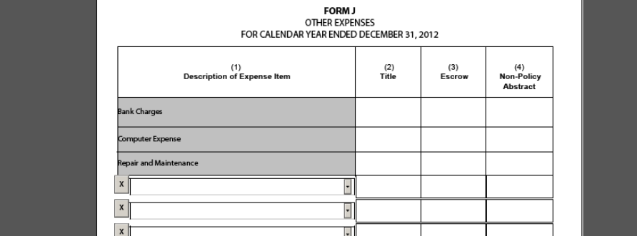

General Information:
Other Expenses (Form J, columns 2, 3, and 4; Form A, line B.32): Include any other necessary expense associated with the title insurance, escrow, or non-policy abstract business not otherwise noted or included in this submission. Do not report distributions, such as partnership or “S-Corp” distributions, on Form J.
This category does not usually represent a significant percentage of an agent’s total expenses. If the amount of other expenses exceeds 2 percent of total expenses (line B.32 line B.33), you must itemize the “other expenses” on Form J. Otherwise, you may enter "other" and show the total amount of other expenses.
Many agents mistakenly include the following expenses in this category: copy charges (B.17), taxes (B.13), legal fees (B.12), and dues (B.22). Do not include these expenses on Form J.

Identification of Owners – Form K
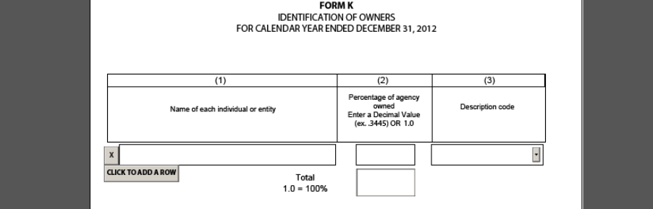

General Information:
List each individual or entity with a direct or indirect ownership interest in the agency greater than or equal to 1 percent. Use the codes on Form K to describe the individual or entity.

Title Insurance Premium by County – Form L
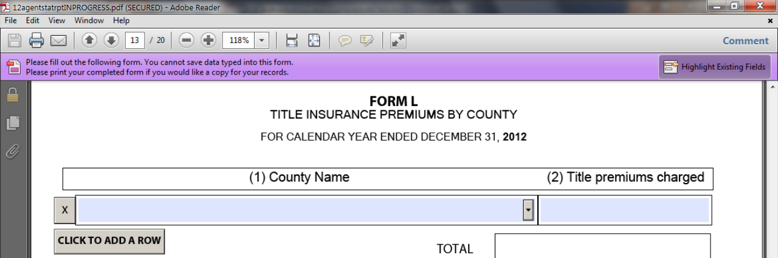

General Information:
The total title premiums charged should equal the amount of total title premiums charged entered in Form B, col. 2. Only report premiums for policies written in counties where you are licensed. Form includes a drop-down listing of Texas county names.

Form A, Section A: Income
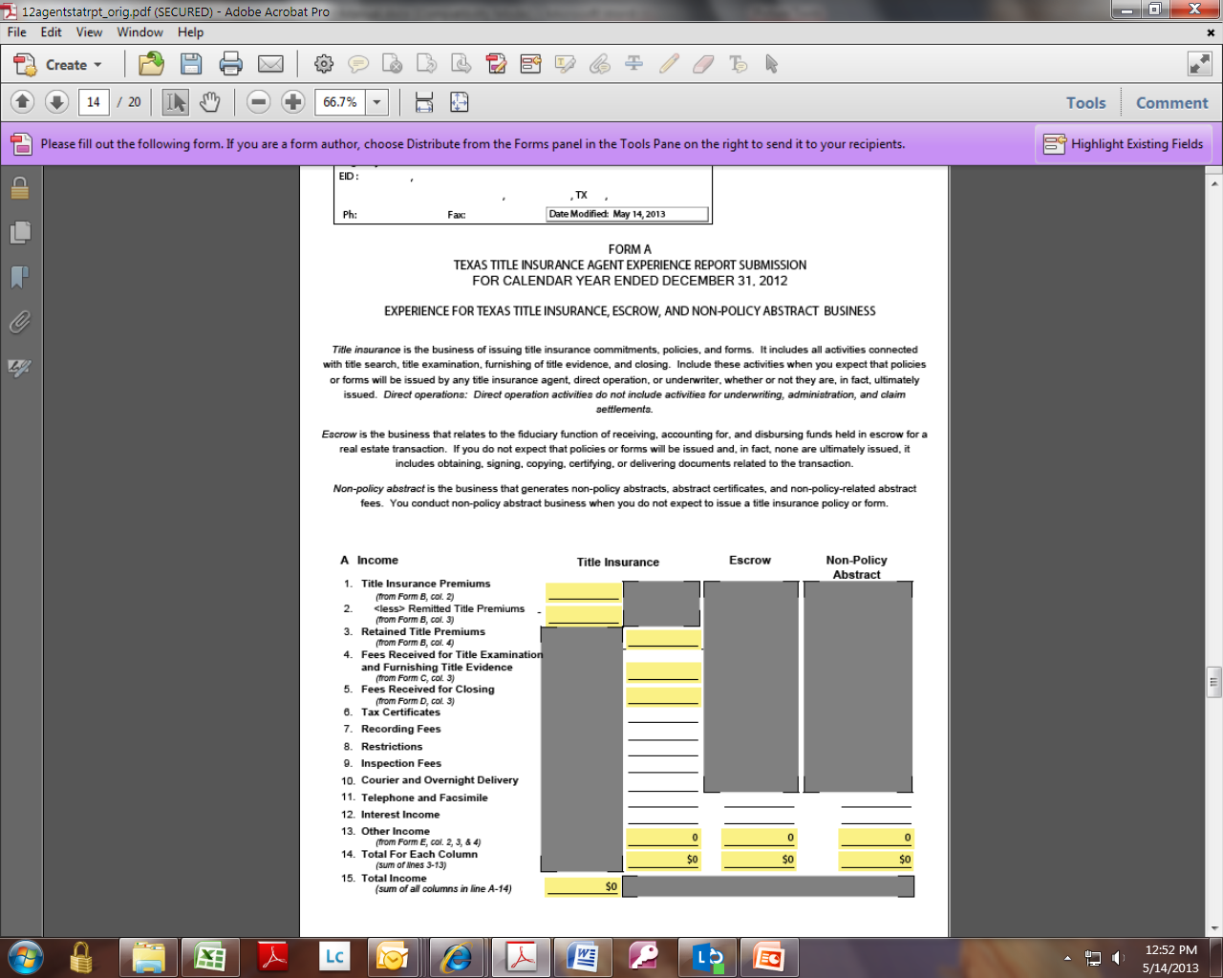

General Information:
Tax Certificates through Telephone and Facsimile (lines A.6 through A.11): Report all income collected for these specific items. These line items are not carried forward from other forms.
Interest Income (line A.12): Do not include interest on funds held in escrow that is paid to the escrow fund owners.
- Direct operations: Do not include interest income on balances supporting underwriting, administration, or claim settlement activities.
Total Income: The sum of all columns in line A.14.

Form A, Section B: Expenses
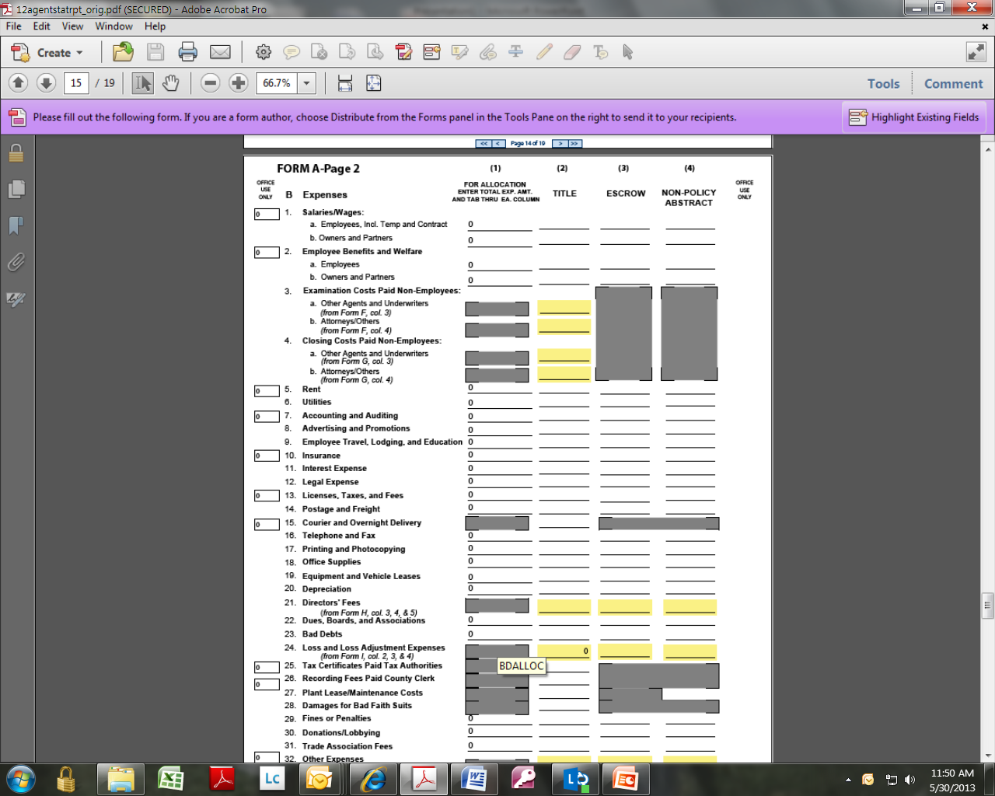

General Information:
General Note Regarding Expenses: Apportion corporate allocations from Form A, Sections E and F, to the appropriate line item expenses, such as salaries, accounting, auditing, data processing, equipment, and so on.
Salaries/Wages (lines B.1a and B.1b): In addition to salaries, include all forms of cash compensation, such as commissions and bonuses. Include any payments for temporary or contract labor.
- Sole proprietorships and partnerships: Include money withdrawn by owner/partner for personal use instead of or in addition to a specific salary.
- Direct operations: Do not include salaries for employees engaged solely in underwriting, administration, or claim settlement functions. Where employees have multiple responsibilities, include only that portion of salaries for the percentage of time devoted specifically to direct operations.
Employee Benefits and Welfare (lines B.2a and B.2b): These include, but are not limited to, group insurance (life, dental, health, and so on); profit sharing and pension plans (including 401(k), ESOP, SEP, etc.); unemployment taxes; payroll taxes; service awards; and company parties or other functions held solely for and attended solely by company directors, officers, and employees and their families.
Form A, Lines B.5 through B.31 are individual expense items. You must report all applicable expenses in their specific categories. Do not use “other expenses” as a catch-all.
Accounting and Auditing (line B.7): Include expenses for in-house or contract services.
Advertising and Promotions (line B.8): Include all expenses incurred for any marketing activity. Include expenses incurred for advertising and promoting the title agency. Also include expenses incurred for activities that educate participants about the business of title insurance, as well as the state and federal laws that regulate the business.
Employee Travel, Lodging, and Education (line B.9): Include all expenses for business travel, including meals and short-term vehicle rentals, while in travel status. Include employee training expenses. Do not include long-term vehicle leases that should be reported on line B.19.
Insurance (line B.10): Include general insurance such as automobile, property, liability, workers compensation, E&O, or fidelity, and title agent and escrow officer bonds. Do not include group insurance plans. Report group insurance plans on line B.2.
Interest Expense (line B.11): Include interest paid or accrued on all short-term or long-term debt obligations.
Legal Expense (line B.12): Include legal fees and retainers for corporate and administrative matters. Do not include costs for defending against a loss. These should be reported on line B.24.
Licenses, Taxes, and Fees (line B.13): These include, but are not limited to, agent, direct operation, and escrow officer licenses, notary bonds, sales tax permits, and property taxes.
Postage and Freight (line B.14): Include postage and freight expenses usual and customary to the operation of any business.
Courier and Overnight Delivery (line B.15): Include courier and overnight delivery charges paid to third-party vendors for the benefit of title insurance customers. Do not include expenses paid for an employee assigned runner/courier duties. Report expenses paid for an employee assigned runner/courier duties on line B.1a.
Telephone and Fax (line B.16): Include monthly telephone service charges as well as dedicated line charges, long distance charges, and other operational charges for facsimile equipment.
Equipment and Vehicle Leases (line B.19): Include all payments for vehicles and other equipment (whether mobile or stationary) acquired through long-term lease agreements. Do not include any short-term vehicle rental expenses for business travel. Report short-term vehicle rentals for business travel on line B.9.
Directors’ Fees (line B.21): Directors’ fees are displayed automatically if entered on Form H in the interactive PDF. If you are submitting the forms manually, bring Form H totals forward to line B.21.
Dues, Boards, and Associations (line B.22): Include only those amounts paid for membership in associations and on boards.
- Do not include any portion of dues used to support political action committees (PACs) or lobbyists. Report those expenses on line B.30.
- Do not include amounts paid to trade associations or clubs. Report trade association expenses on line B.31. Report club memberships as employee benefits on line B.1b, or as advertising and promotions on line B.8.
Bad Debts (line B.23): Include only obligations due to this agency that were written off the books as uncollectible during the calendar year.
Loss and Loss Adjustment Expenses (line B.24): Losses are displayed automatically if entered on Form I in the interactive PDF. If you are submitting the forms manually, bring Form I totals forward to line B.24.
Tax Certificates Paid to Tax Authorities (line B.25): Include any amounts paid to taxing authorities or to tax services for providing tax information.
Recording Fees Paid to the County Clerk (line B.26): Include only fees paid to the county clerk for the recording of instruments.
Plant Lease/Maintenance Costs (line B.27): Allocate these costs directly to the title insurance column, except to the extent that you can make equitable and reasonable allocations to the non-policy abstract column.
Donations/Lobbying (line B.30): "Donations" means charitable contributions. "Lobbying expenses" includes amounts paid to PACs and individual lobbyists whether you pay these amounts directly to the PAC or lobbyist, or indirectly through other organizations. Do not include amounts paid to trade associations. Report amounts paid to trade associations on line B.31.
Trade Association Fees (line B.31): Include amounts paid to organizations that provide professional services as well as lobbying, such as trade associations.

Form A, Section C: Net
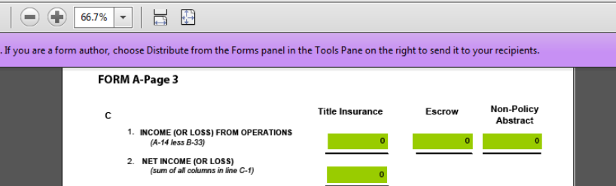

General Information:
Income (or Loss) from Operations (line C-1): The interactive PDF form calculates these totals for you from the information you enter. If these numbers do not agree with your calculations, complete the rest of the submission, then review your forms and revise any errors. The title agency experience report submission should reconcile with the net income reported on the title agency financial statements for these three business areas.

Form A, Section D: Policy Count
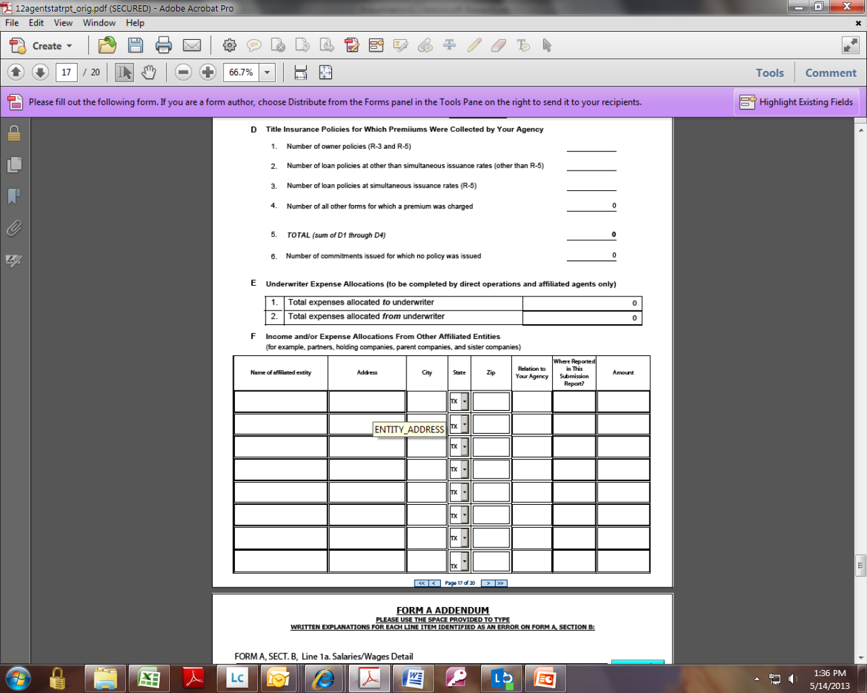

General Information:
Line D-1: Include the number of owner’s policies issued under Rate Rules R-3 and R-5 (simultaneous issuance).
Line D-2: Include the number of loan policies issued at other than simultaneous issuance rates.
Line D-3: Include the number of loan policies issued under Rate Rule R-5 (simultaneous issuance).

Form A, Section E: Underwriter Expense Allocations

General Information:
Total Expenses Allocated to Underwriter by Direct Operation or Affiliated Agent Only: Include costs that the direct operation or affiliated agent actually expended, but that were allocated to the underwriter for purposes of the experience report submission. This is an aggregate amount of all such expenses excluded from the agent’s experience report submission.
Total Expenses Allocated from Underwriter by Direct Operation or Affiliated Agent Only: Include costs that the underwriter actually expended in its underwriting, administration, or claim settlement activities, but that were allocated to the direct operation or affiliated agent for purposes of the experience report submission. This is an aggregate amount of all such expenses excluded from the underwriter’s experience report submission.

Form A, Section F: Affiliated Entities

General Information:
Income and/or Expense Allocations from Other Affiliated Entities: For income and expense items reported on Form A, specify if allocations were made from other affiliated entities. For this section, other affiliated entities include, but are not limited to, parent and sister companies, holding companies, and partners. Include the line and item number on which the allocation is reported.

Form A: Addendum


General Information:
For providing additional information to explain or justify form errors. The last box on the Addendum page can be used to voluntarily provide additional documentation. Include the form, section, and line item in your explanation.

EMAIL ADDRESSES

Under most circumstances, individual email addresses are protected by the Texas Public Information Act. Sharing this information for purposes of processing your information does not waive these confidentiality protections. However, you may affirmatively consent to release of your email address in response to a public information request or inquiry. If you would like more information about the public or confidential nature of information maintained by TDI, please consult our Open Records Policy and our Web Site Privacy Policy. This form is encrypted to meet privacy requirements.

NOTICE ABOUT CERTAIN INFORMATION, LAWS, AND PRACTICES

With few exceptions, you are entitled to be informed about the information that the Texas Department of Insurance (TDI) collects about you. Under sections 552.021 and 552.023 of the Texas Government Code, you have a right to review or receive copies of information about yourself, including private information. However, TDI may withhold information for reasons other than to protect your right to privacy. Under section 559.004 of the Texas Government Code, you are entitled to request that TDI correct information that TDI has about you that is incorrect. For more information about the procedure and costs for obtaining information from TDI or about the procedure for correcting information kept by TDI, please contact the Office of Agency Counsel in the Legal Section of the General Counsel Division at AgencyCounsel@tdi.texas.gov or visit the Corrections Procedure section of TDI's web page at www.tdi.texas.gov.

